Innovative ideas for smart parking system

**Finding a parking spot in the city is the one driving maneuver that causes drivers the most stress. However, the application of smart parking technology, according to [Libelium](https://www.libelium.com/iot-solutions/smart-parking/), a provider of technology solutions based on the Internet of Things (IoT), reduces traffic volume by 8%, gas emissions by 40%, the distance driven by a car to park by 30%, and the amount of time needed to park by 43%.**

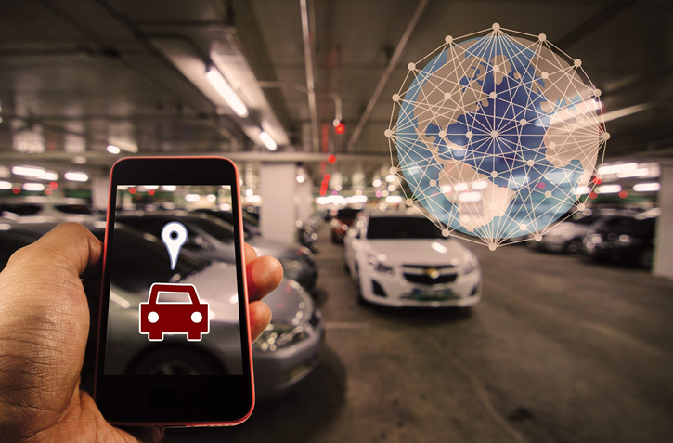

**Smart parking systems are beginning to provide answers for urban transportation as a result of digitization. This system enables the acquisition of real-time data about parking availability and information about traffic and road conditions. This is made possible through the Internet of Things and sensor technologies.**

**The structure of smart parking is made up of several tools and procedures that serve as parking space detectors. On the one hand, the installation of cameras and/or sensors that capture, analyze, and present data and images to deliver real-time traffic occupancy statistics for the location we are going. On the other hand, an IoT cloud-based system enables the connection of various devices and the centralization of the data. The availability of parking spaces is then determined using big data analysis of the data.**

**In this article, you will learn about 5 hidden gems boosting corporate innovation in the smart parking industry. The +2 million companies’**[**Novable**](https://novable.com/startup-scouting-for-corporate-innovation/)**database never disappoints.**

5 Innovative solutions in the smart parking industry

* **Voice park**
* **Yazamtec**
* **Nwave**
* **Smart City System**
* **Parquery**

**1. VoicePark**

**Being a key player in the parking sector has always been a priority for [VoicePark](https://www.voicepark.org/). The first step was developing an innovative smartphone app that improves and sustains urban mobility. VoicePark was the first to direct vehicles turn-by-turn to open on-street parking spaces in real-time during the test with the San Francisco Municipal Transportation Agency (SFMTA). The team managed to cut down the time it took for cars to find a parking space in San Francisco from 12.5 minutes to 45 seconds using proprietary algorithms.**



**2. Yazamtec**

[**Parking Hero Matrix**](https://www.yazamtec.com/)**is a blockchain-based solution for parking management, monetization, and enforcement. The technology makes it possible to incorporate any parking space – on-street, off-street, private, commercial, or individual – into a global distributed ledger.**

**The irreversible and unchangeable nature of the ledger enables all parties involved to transact in a highly transparent, secure, and reliable manner. They have immediate access to the settlement information, thus there is no need for expensive processing or financial reconciliations.**

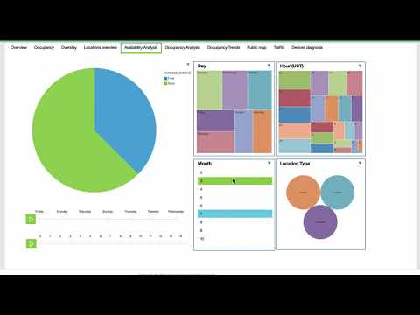

**3. Nwave**

**One of the market-leading wireless parking management solutions was created by [Nwave.](https://www.nwave.io/) It assists operators of parking assets and providers of smart parking solutions in streamlining their operations.**

**Nwave meets and exceeds the needs of end users and parking system integrators in terms of technical accuracy, reliability, and functionality. Additionally, it eases solution installation and data/API integration.**



**4. Smart City System**

[**Smart city system**](https://smart-city-system.com/en/home/)**produces smart parking sensors that wirelessly transmit the current occupancy status of your parking spot. Their user-friendly software allows you to view the parking information, and it can also be easily linked to your current system. Parking sensors from smart city systems are entirely wireless, simple to install, and immediately operational.**



**5. Parquery**

**Any type of parking space, whether indoors or outside, permanent or temporary, continually or irregularly, in good or bad weather, can be searched in real-time using [Parquery](https://parquery.com/).**

**Parquery is a tried-and-true partner for end users seeking a smart parking solution to manage their spaces. Moreover, it serves distributors, system integrators, and parking industry manufacturers seeking a technology partner to expand their portfolio.**



**Smart parking has many benefits:**

* **Maps. Access to real-time traffic information and parking availability.**
* **Signage. Road-sign systems are also utilizing smart technologies in an effort to improve safety and effectively manage traffic flow. Examples include pedestrian crossings and traffic lights that alter their color or brightness in response to actual or projected traffic loads, such as peak periods.**
* **Detectors for vehicles. The foundation of smart parking is knowing precisely how many vehicles are present in a parking lot at any one moment. The sensor system used in this vehicle presence detection feature includes dual channel loop detectors, ultrasonic presence sensors, and LiDAR vehicle sensors. They offer accurate vehicle locations, determine whether a parking garage is full, and detect whether a parking space is free or occupied.**
* **Parking spot occupancy. In this instance, these sensors identify open parking spaces, making it easier for vehicles to find open parking places in closed areas. Drivers can see how many parking spaces are available thanks to the addition of LED indicators. The red and green lights show whether the parking space is being utilized right away or is available for parking.**